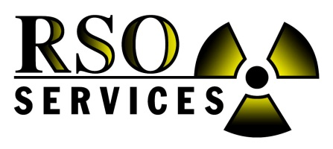

Radiation Safety Officer School

ON-SITE School in 2017
To be held at your plant and in your training room.

40-Hour Course

Offered by:

RSO SERVICES, Inc.

When: Customer picks the week, Monday - Friday, Year 2017
(weekends are possible but will be billed over-time)

- The 40 hour course is a 5 day, 8 hour/day school (Mon. – Fri.)
or 4 day, 10 hour/day school (Mon - Thur.)
- Class time is 8:00 AM to 4:00 PM each day (or as requested by the company).

Instructor: Dr. Michael L. Hensley

Option 1- If customer site is within 500 miles of Jasper, Alabama: $10,200.00 total price for 6 students (all travel time, transportation and expenses included). $1,050.00 per additional student.

Option 2 - If customer site is greater than 500 miles of Jasper, Alabama: $12,200.00 total price for 6 students (all travel time, transportation and expenses included). $1,050.00 per additional student. Alaska and Hawaii add $2,000.00. International location requires custom quote.

Course includes a complete training book and 40 hr RSO Certificate per student upon completion.

Course Description:
This class will introduce you to the regulations and safety aspects of handling fixed nuclear devices. It will help you design your own safety program and answer many safety questions that plant employees have. You will learn basic radiation theory, how to monitor and measure radiation, D.O.T. requirements, radiation procedures, both operating and emergency procedures, health effects, how to apply or renew licenses, State and NRC regulations and all that is needed to run a correct safety program at your facility. This course is approved and certified by the State of Alabama Department of Public Health, State of Georgia, Mississippi, Florida, Tennessee, South Carolina, North Carolina, Louisiana DEQ and most other state agencies throughout the country. Many states will not certify any 40 hr RSO course, but will approve or deny a class when submitted by the student. We have never had our 40 hour RSO class denied. Instead, many states recommend our class for the Industrial experience we provide.
In addition, while on-site the teacher can provide training on customer’s radiation gauges and review safety procedures.

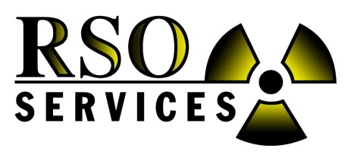
Radiation Safety Officer School
ON-SITE, Customer’s Plant
1 week in 2017

Four Easy Ways to Register:

- Mail this form 2. Call: 850-651-0777 or 205-924-1891
- Fax: 866-254-3211 4. Email: mike@rsoservices.com and cc: info@rsoservices.com

Send PO to: RSO Services, Inc., Attn: Accounts Payable, PO Box 575, Niceville, FL 32588

Company Name: _________________________________ Contact Name: ______________________________

Company Address: _____________________________________________________________________________

Land Phone: _____________________________ Cell Phone: ____________________________________

Fax: ____________________________________ Email: ________________________________________

ATTENDING STUDENTS

Name 1 ______________________________________ Name 6________________________________________

Name 2 ______________________________________ Name 7________________________________________

Name 3 ______________________________________ Name 8________________________________________

Name 4 ______________________________________ Name 9________________________________________

Name 5 ______________________________________ Name 10_______________________________________

Option 1- If customer site is within 500 miles of Jasper, Alabama: $10,200.00 total price for 6 students (all travel time, transportation and expenses included). $1,050.00 per additional student.

Option 2 - If customer site is greater than 500 miles of Jasper, Alabama: $12,200.00 total price for 6 students (all travel time, transportation and expenses included). $1,050.00 per additional student. Alaska and Hawaii add $2,000.00. International location requires custom quote.

Please Select: _____ Option 1 ($3,570.00 deposit) _____Option 2 ($4,270.00 deposit)

Billing Contact: ______________________________ Email: ________________________________________

Billing Address: _____________________________________________________________________________

Land Phone: _____________________________ Cell Phone: ____________________________________

Course includes a complete training book and 40 hr RSO Certificate per student upon completion.

IMPORTANT: This on-site school is for 1 company only. Additional students from other companies must pay $1,295.00 each (discounted rate). A 35% deposit or full payment is required to reserve the week. Deposit is non-refundable and non-cancelable unless written authorization is given by Robert Harrison.

